**Chapter 2**

**Limits**

**2.5 The Precise Definition of a Limit**

**Section Exercises**

**In the following exercises, write the appropriate  definition for each of the given statements.**

177. 

Answer: For every , there exists a , so that if , then ]

179. 

Answer: For every , there exists a , so that if , then ]

**The following graph of the function *f* satisfies . In the following exercises, determine a value of  that satisfies each statement.**

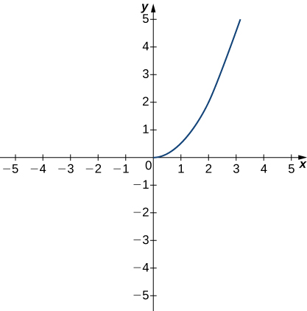

181. If , then .

Answer: 

**The following graph of the function *f* satisfies . In the following exercises, determine a value of  that satisfies each statement.**

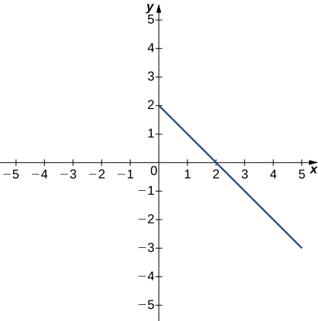

183. If , then .

Answer: 

**The following graph of the function *f* satisfies . In the following exercises, for each value of *ε*, find a value of  such that the precise definition of limit holds true.**

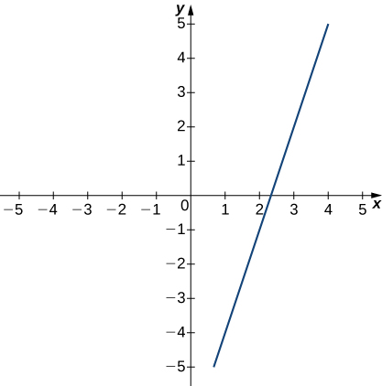

185. 

Answer: 

**[T] In the following exercises, use a graphing calculator to find a number *δ* such that the statements hold true.**

187. ,whenever

Answer: 

**In the following exercises, use the precise definition of limit to prove the given limits**.

189. 

Answer: Let . If, then.

191. 

Answer: Let . If , then.

**In the following exercises, use the precise definition of limit to prove the given one-sided limits.**

193. 

Answer: Let . If , then .

195. , where .

Answer: Let  If , then .

**In the following exercises, use the precise definition of limit to prove the given infinite limits.**

197. 

Answer: Let . If , then .

199. An engineer is using a machine to cut a flat square of Aerogel of area 144 cm2. If there is a maximum error tolerance in the area of 8 cm2, how accurately must the engineer cut on the side, assuming all sides have the same length? How do these numbers relate to *δ*, *ε*, *a*, and *L*?

Answer: 0.033 cm, , , , 

201. Using precise definitions of limits, prove that does not exist, given that  is the ceiling function. (*Hint*: Try any .)

Answer: Answers may vary.

203. Using precise definitions of limits, determine  for . (*Hint*: Break into two cases, *x* rational and *x* irrational.)

Answer: 0

**For the following exercises, suppose that  and  both exist. Use the precise definition of limits to prove the following limit laws:**

205. 

Answer: 

207. . (*Hint*: .)

Answer: Answers may vary.

**Chapter Review Exercises**

***True or False*. In the following exercises, justify your answer with a proof or a counterexample.**

209. You can use the quotient rule to evaluate .

Answer: False

211. If  does not exist, then *f* is undefined at the point .

Answer: False. A removable discontinuity is possible.

**In the following exercises, evaluate the limit algebraically or explain why the limit does not exist.**

213. 

Answer: 5

215. 

Answer: 

217. 

Answer: DNE

219. 

Answer: 

221. 

Answer: –4

**In the following exercises, use the squeeze theorem to prove the limit.**

223. 

Answer: Since , then  . Since  , it follows that .

225. Determine the domain such that the function  is continuous over its domain.

Answer: 

**In the following exercises, determine the value of *c* such that the function remains continuous. Draw your resulting function to ensure it is continuous.**

227. 

Answer: 

**In the following exercises, use the precise definition of limit to prove the limit.**

229. 

Answer: 

231. A particle moving along a line has a displacement according to the function  where *x* is measured in meters and *t* is measured in seconds. Find the average velocity over the time period .

Answer: 

This file is copyright 2016, Rice University. All Rights Reserved.